Chapter 10, Problem 92.

The oscillator circuit in Fig. 10.134 uses an ideal op amp.

(a) Calculate the minimum value of R_{o} that will cause oscillation to occur,

(b) Find the frequency of oscillation.
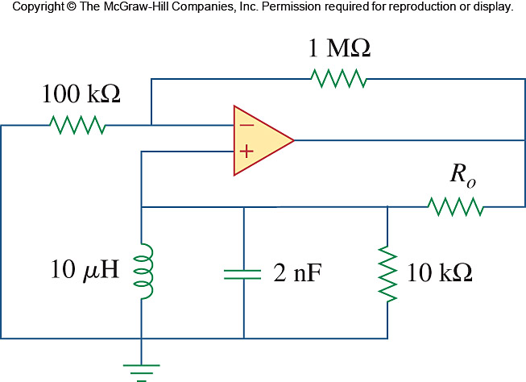

Figure 10.134
For Prob. 10.92.

